Infosys Springboard Virtual Internship 6.0 – Completion Report

Team Details
Batch Number | 1
Project Title | SmartStock – Inventory Optimization for Retail Stores
Start Date | 10 Nov 2025
Internship Duration | 8 Weeks
Names of Team Members | 4
1. Project Title
SmartStock – Inventory Optimization for Retail Stores
2. Project Objective
The objective of the SmartStock Inventory Optimization for Retail Stores project is to design and develop an intelligent inventory management solution that forecasts product demand, prevents stockouts and overstocking, and improves store-level operational efficiency. The system helps managers monitor real-time stock levels, analyze sales trends, generate alerts for low-stock products, and optimize replenishment decisions using data-driven insights. By providing centralized control and analytics dashboards, SmartStock aims to reduce inventory costs, minimize wastage, and enhance customer satisfaction through timely product availability.
3. Project Description in Detail
SmartStock is an inventory optimization system built for retail stores to simplify and automate stock management processes. The solution integrates product information, sales data, and stock transactions to provide real-time visibility of inventory levels across stores. The application supports functions such as product registration, stock updates, transaction logging, sales analytics, and alert notifications for low-stock items.
The system dashboard allows managers to quickly review key performance metrics such as total sales, monthly averages, and trend growth. Sales analytics modules visualize product-wise sales and revenue through interactive charts and graphs. These insights help store managers identify fast-moving and slow-moving products, analyze seasonal variations, and take informed restocking decisions.
A role-based login system ensures secure access for managers and staff. The tool also supports report generation so that sales and inventory summaries can be downloaded for audits and management review.
4. Timeline Overview
Week Activities Planned
Week | Activities Planned | Activities Completed
Week 1 | Requirement gathering, defining problem statement, and identifying key system features | Requirements finalized and scope documented
Week 2 | Research on inventory management techniques and technology stack finalized and architecture designed | Technology stack finalized and architecture designed
Week 3 | Database design and schema development | Database created and tested with sample data
Week 4 | Development of basic modules like product and stock management | Core modules for product and stock completed
Week 5 | Development of analytics and dashboard components | Sales analytics dashboard implemented
Week 6 | Integration of modules and implementation of alert notifications | System integration completed with alert mechanism
Week 7 | Testing and debugging of complete application | Functional and UI testing completed
Week 8 | Final deployment and documentation | Application deployed and final report prepared
5a. Key Milestones
Milestone | Description | Date Achieved
Project Kickoff | Defined objectives, scope, and project plan | 10 Nov 2025
Prototype/First Draft | Basic inventory dashboard and stock module developed | 25 Nov 2025
Mid-Term Review | Demonstrated core functionality and received feedback | 10 Dec 2025
Final Submission | Completed SmartStock system with analytics and reporting | 05 Jan 2026
Presentation | Presented project outcomes, demo, and results | 08 Jan 2026

Milestone Summary
Project Kickoff | Prototype/First Draft | Mid-Term Review | Final Submission | Presentation
✓ | ✓ | ✓ | ✓ | ✓
5b. Project Execution Details
Requirement Analysis
Identified challenges in manual inventory handling and defined system requirements.
- Technology Selection – Chose appropriate frontend, backend, database, and visualization tools.
- System Design – Designed ER diagrams, workflows, and user interface wireframes.
- Data Collection – Prepared sample stock and sales datasets for testing and validation.
- Data Preprocessing – Cleaned and structured transaction data for analytics.
- Model Development – Implemented basic demand forecasting and sales trend analysis logic.
- Frontend Development – Built dashboards, forms, and navigation pages for users.
- Backend Development – Developed APIs and business logic for inventory operations.
- Testing & Integration – Performed unit and integration tests to ensure smooth functioning.
- Deployment & Documentation – Hosted project and prepared user manual and completion report.
6. Snapshots / Screenshots
Step 1: Open the SmartStock Application
In this step, the user opens the SmartStock Inventory Management System. The landing screen provides access to various modules through the left-side navigation menu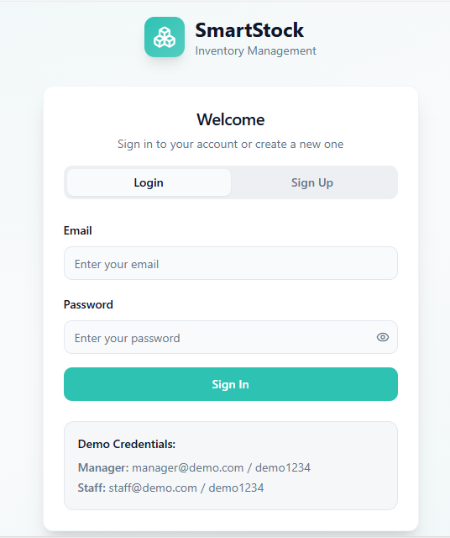
Step 2: Login to the System
The user logs into the application using valid credentials. Role-based authentication ensures that only authorized users such as managers can access inventory functions.

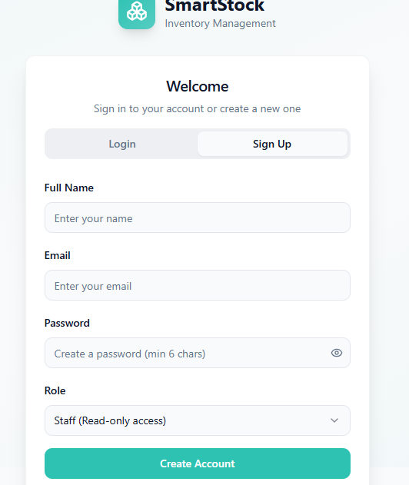

Step 3: Dashboard Overview
After login, the dashboard displays a summary of total products, stores, stock status, and notifications. It provides a quick overview of inventory performance (staff account)

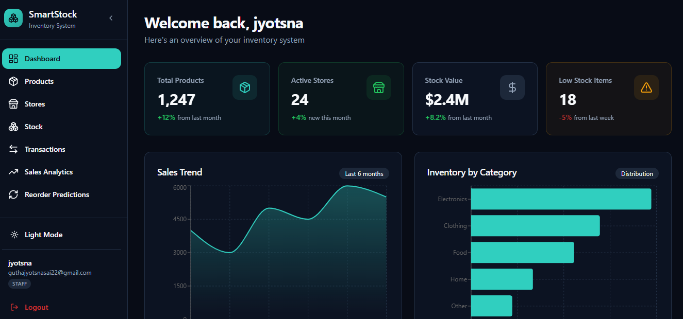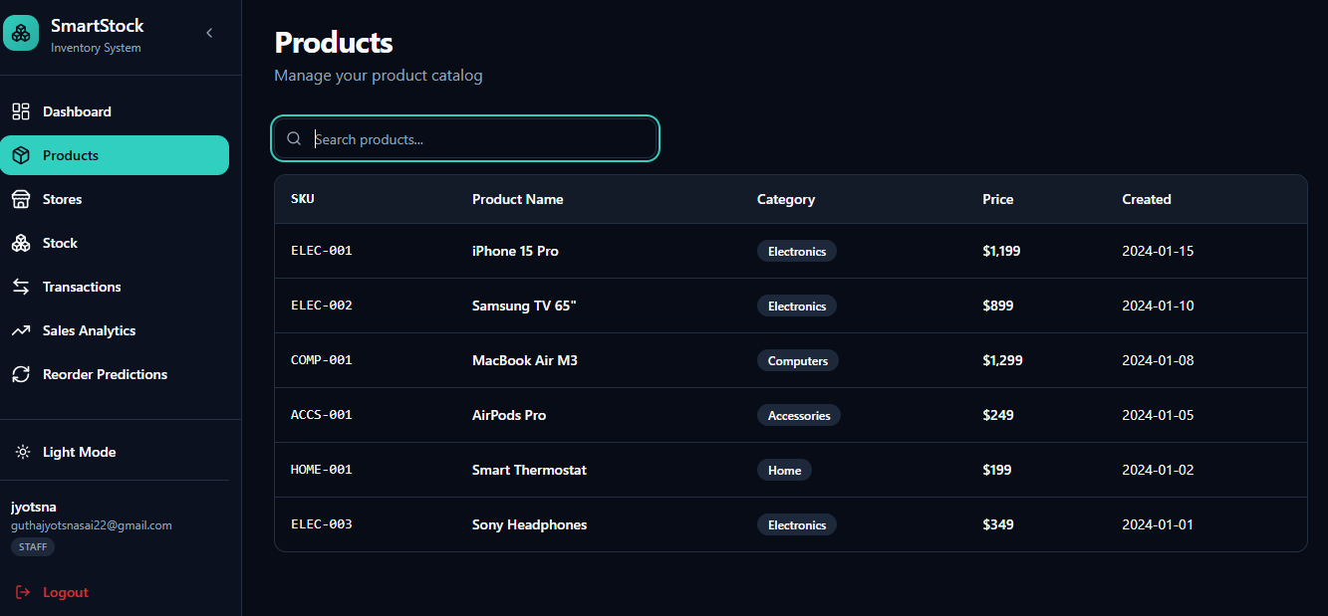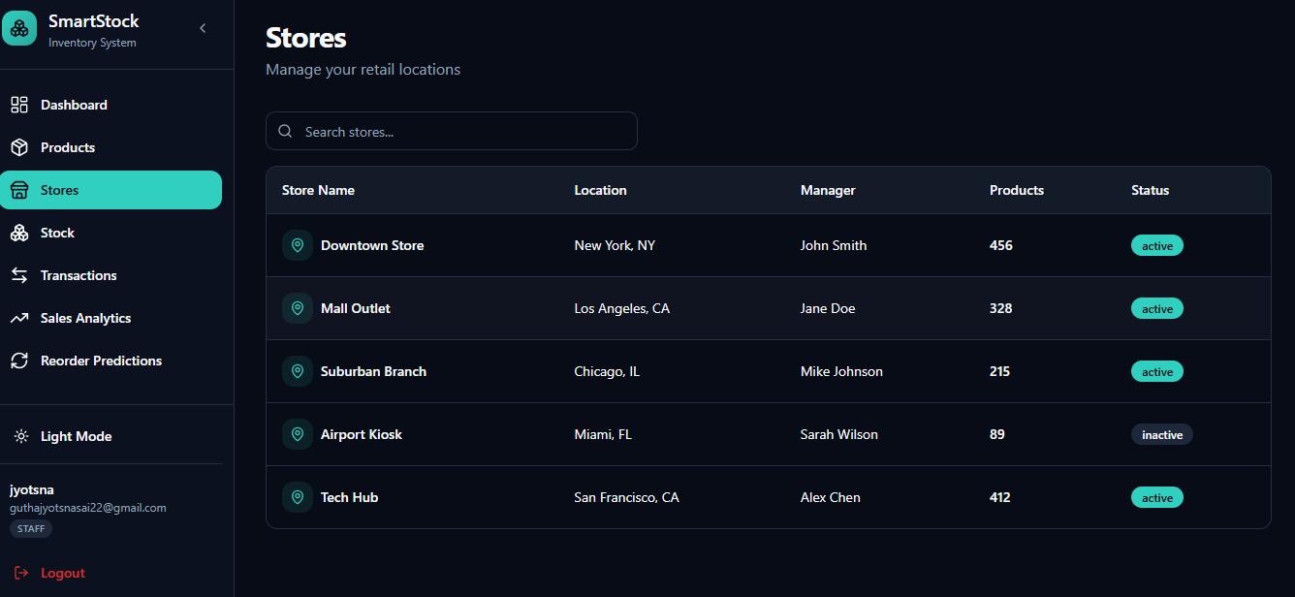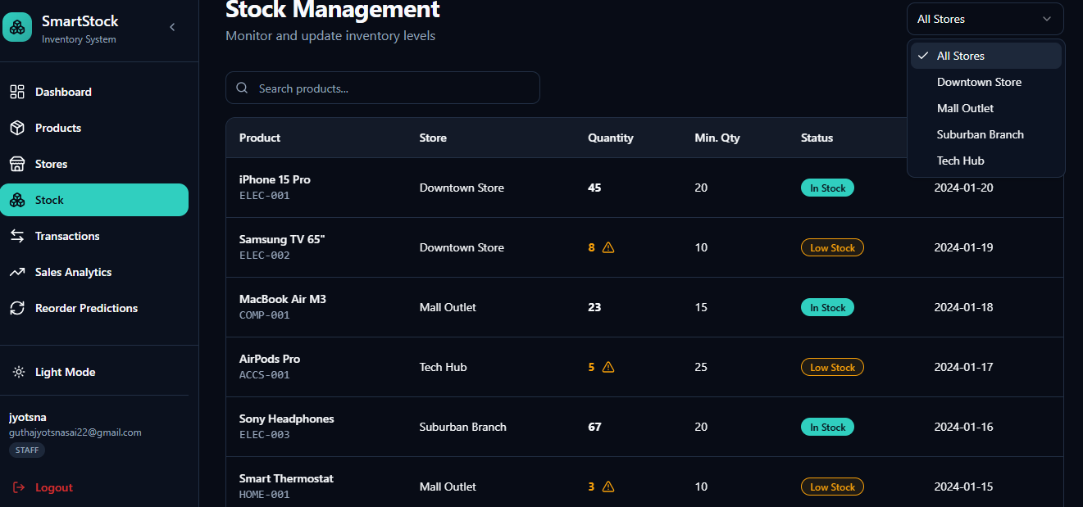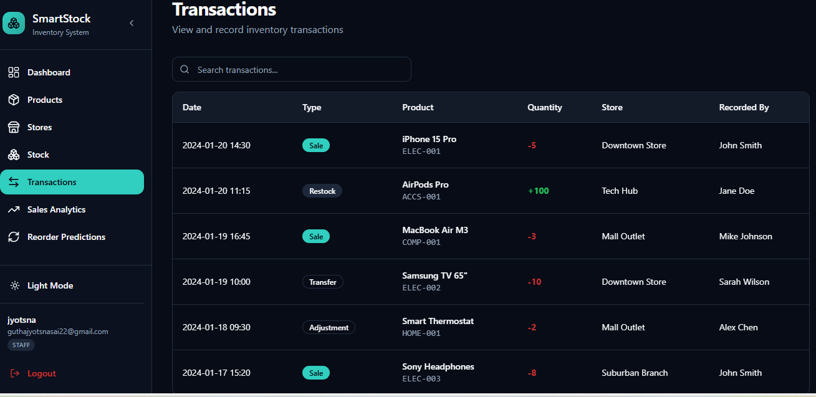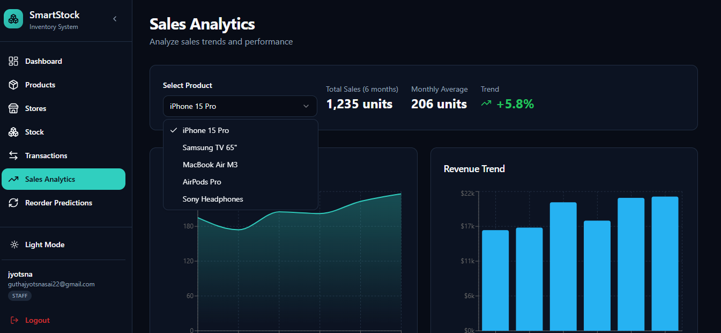
Step 4: Viewing Sales Analytics
This screen shows the Sales Analytics page where users analyze sales trends and performance for different products.
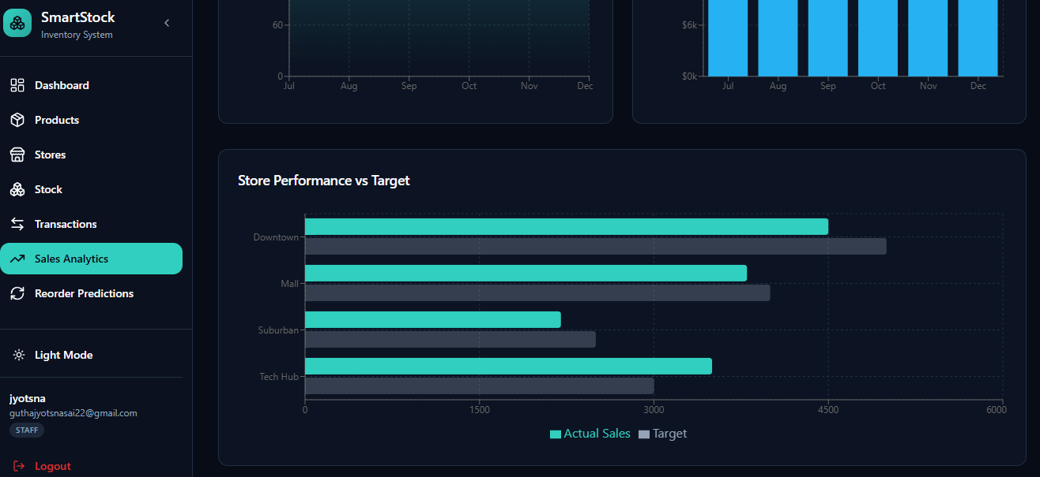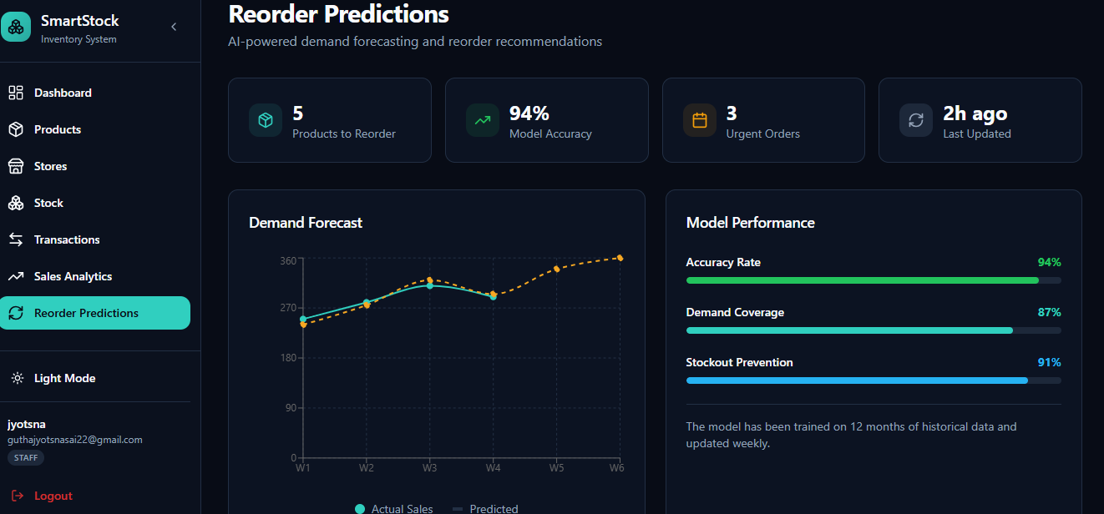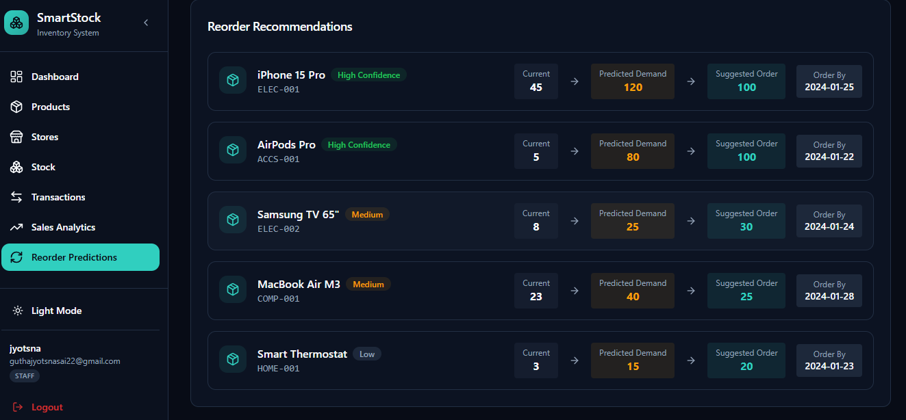
Step 5: Sales Trend Graph
This screen displays the Sales Trend – iPhone 15 Pro line graph, showing monthly sales patterns over six months.

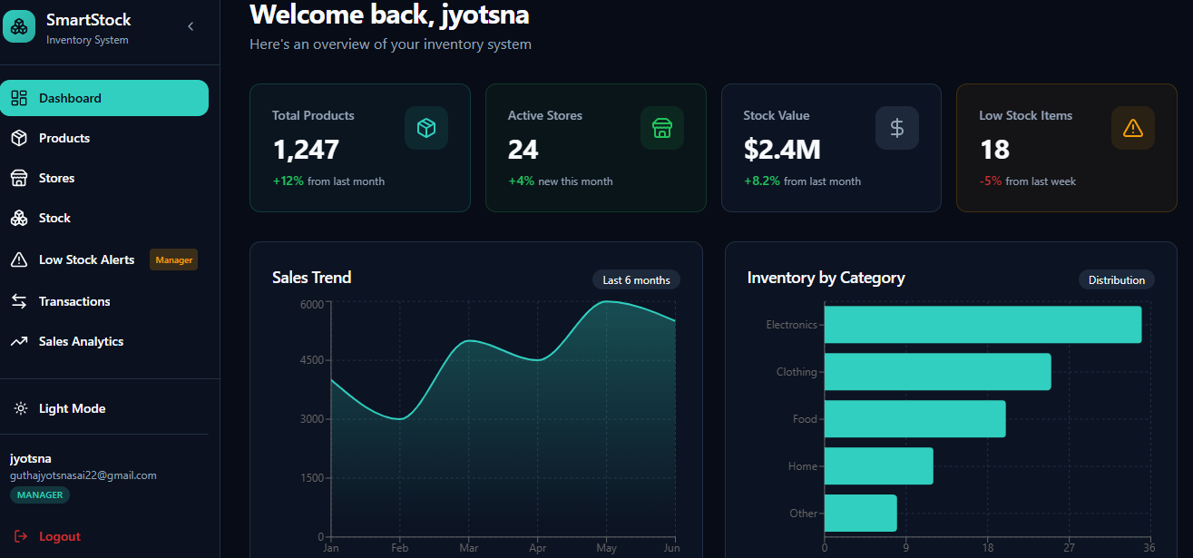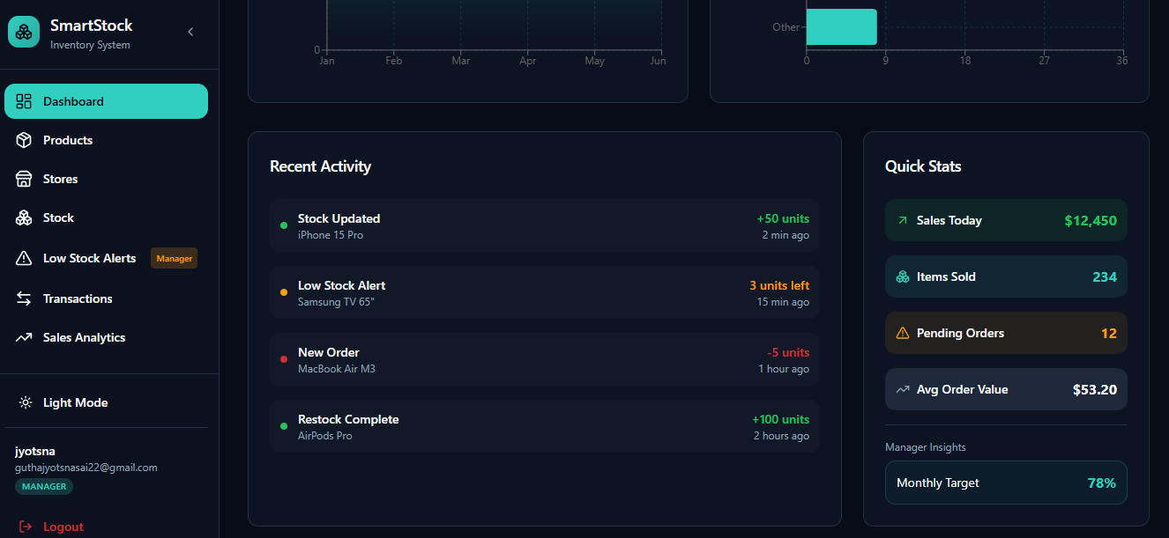

Step 6: Adding a New Product
The user can add new inventory items by entering product details such as name, category, price, and quantity.

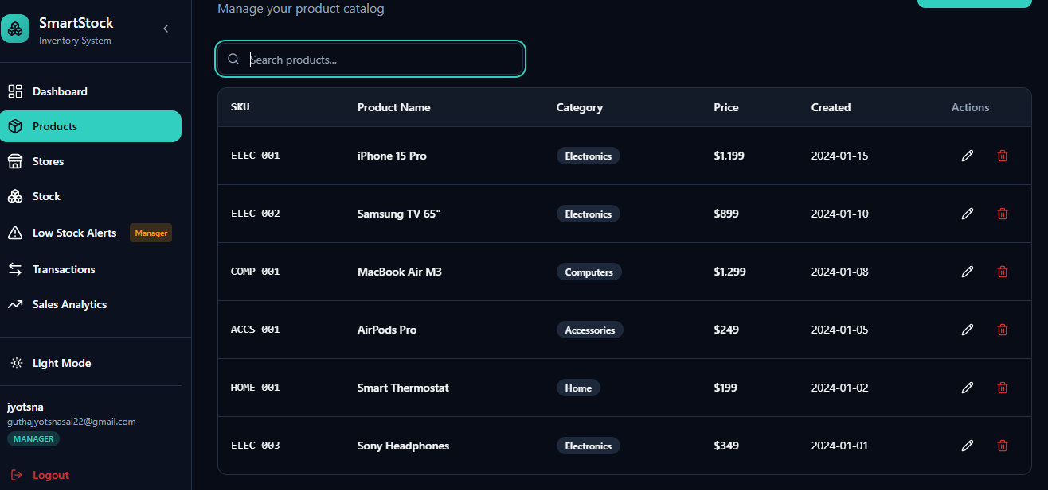

Step 7: Low Stock Alerts
The system generates alerts for products that reach minimum stock levels, helping avoid stockouts and lost sales.
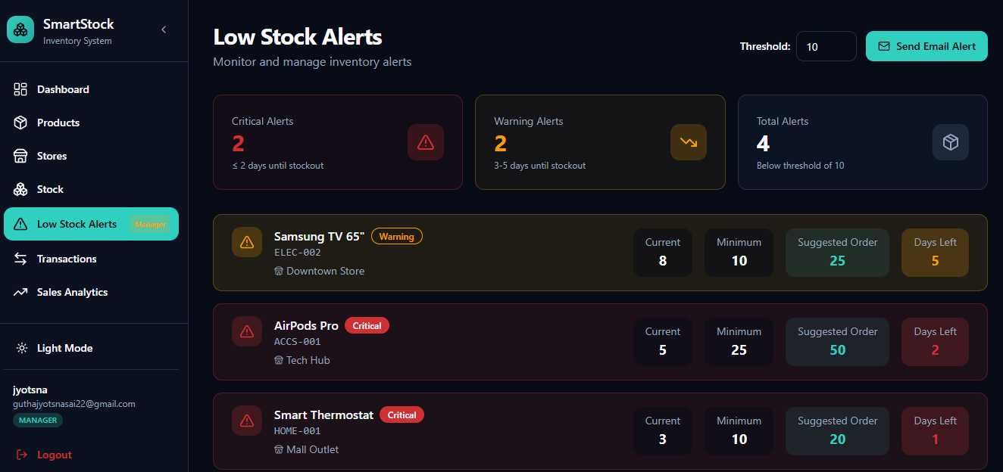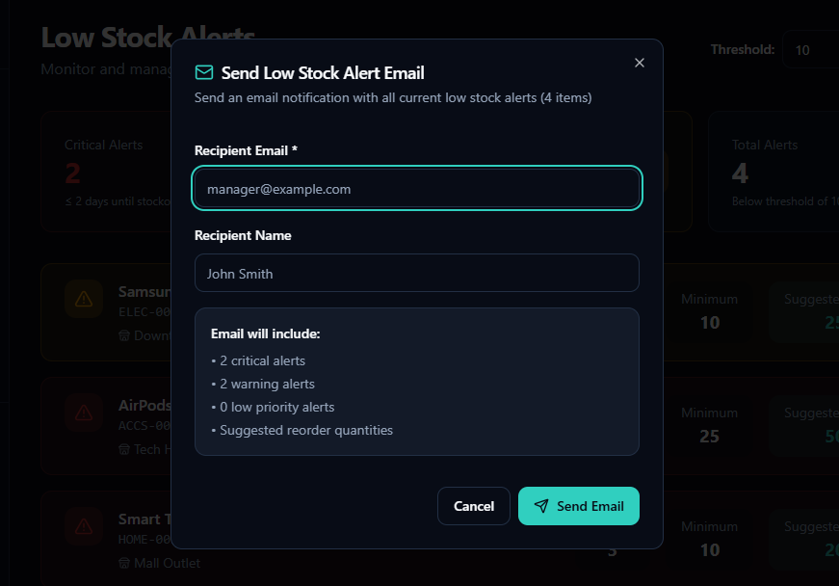

Step 8: Adding Stock Transactions
This screen shows stock-in and stock-out transactions being recorded for proper tracking of inventory levels.
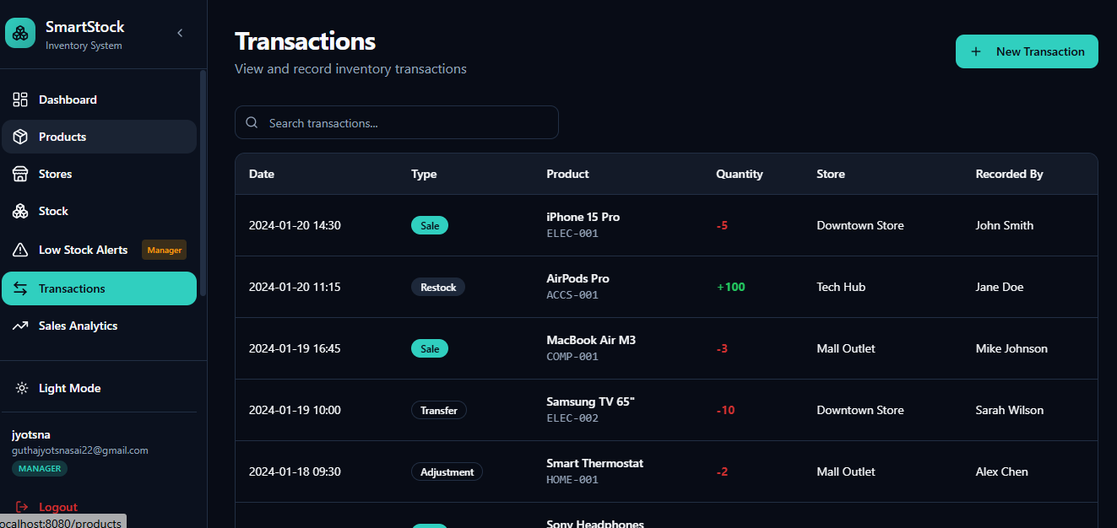Step 9: Revenue Trend Graph
This screenshot shows the Revenue Trend bar chart, representing monthly revenue comparison based on product sales.

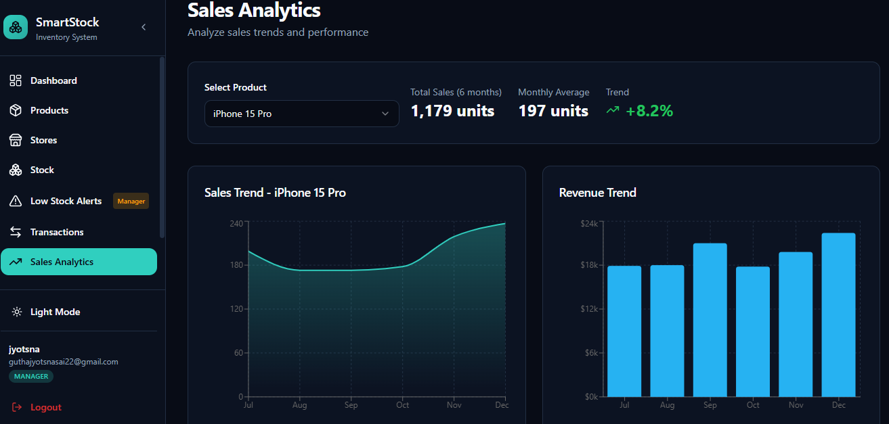

7. Challenges Faced
• Inventory Data Consistency – Ensuring accuracy of stock records across products and stores required continuous validation.
• Demand Variability – Fluctuating sales patterns made demand prediction and replenishment planning challenging.
• Integration of Modules – Connecting product, stock, transaction, and analytics modules into a unified system required careful coordination.
• Dashboard Design – Designing intuitive dashboards that clearly conveyed key metrics without clutter involved multiple refinements.
• Low-Stock Alert Logic – Defining appropriate thresholds and reducing false alerts required iterative tuning.
• Role-Based Access Control – Implementing secure authentication and differentiated permissions added design complexity.
• Performance Optimization – Handling multiple transactions and analytics processing without latency required optimization efforts.
• Testing Diverse Scenarios – Verifying stock-in, stock-out, returns, and multi-store operations demanded extensive testing.

8. Learnings & Skills Acquired
• Inventory Management Concepts – Gained practical understanding of stock tracking, reorder levels, and retail workflows.
• Full-Stack Development – Enhanced knowledge of frontend, backend, and database integration for real-time applications.
• Data Analytics & Visualization – Learned to create dashboards and charts for sales and revenue insights.
• Database Design – Strengthened skills in schema design, relationships, and query optimization.
• System Integration – Acquired experience integrating multiple modules into a single cohesive system.
• Problem-Solving Skills – Improved ability to debug functional and logical issues in live applications.
• Software Development Life Cycle – Experienced requirement analysis, design, implementation, testing, and deployment phases.
• Team Collaboration – Improved coordination, task-sharing, and communication within a project team.

9. Testimonials from Team
Team Member 1: "Working on SmartStock strengthened my understanding of inventory workflows and improved my ability to design efficient database systems."
Team Member 2: "This project helped me gain practical experience in building dashboards and analyzing sales and revenue trends through visualization tools."
Team Member 3: "SmartStock enhanced my collaborative skills and taught me how to integrate multiple modules into a single functioning application."
Team Member 4: "I developed greater confidence in backend development, API integration, and handling real-time transaction data during this project."

10. Conclusion
The SmartStock – Inventory Optimization for Retail Stores project successfully delivered a comprehensive inventory management solution capable of tracking products, monitoring stock levels, and analyzing sales and revenue trends. The system improves decision-making through visual analytics and automated alerts, helping retail managers minimize stockouts and excess inventory. The project provided significant hands-on experience in application development, data handling, and system integration, and contributed to a deeper understanding of retail inventory operations.

11. Acknowledgements
We would like to extend our sincere appreciation to Infosys Springboard for providing the opportunity to undertake the project titled “SmartStock – Inventory Optimization for Retail Stores.” The internship offered valuable exposure to real-world software development practices and enhanced our understanding of inventory optimization and data-driven decision-making in retail environments.
We are deeply grateful to our mentor shakthi Gopalakrishnan madam
for their consistent guidance, insightful feedback, and encouragement throughout the duration of the internship. Their support was instrumental in refining the project and successfully achieving the defined objectives.
We would also like to acknowledge the efforts and cooperation of our team members. Their professionalism, collaboration, and commitment played a key role in the successful completion of this project.
Finally, we thank all individuals who directly or indirectly supported and encouraged us during the internship and contributed to the completion of this project.

